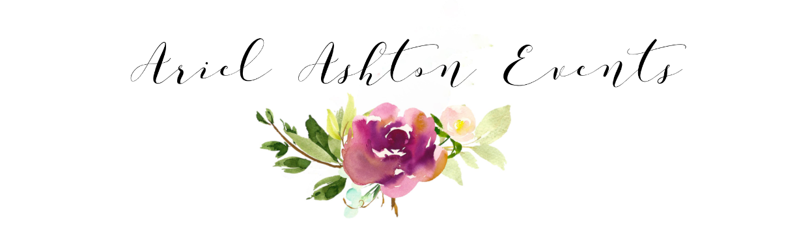
Pre-Consultation Wedding Questionnaire

CONTACT INFORMATION

First Name: Last Name:
Phone Number:
Email Address:
Mailing Address:

Fiancés First Name: Fiancés Last Name:
Fiancés Email:
Fiancés Phone Number:
Mailing Address:

WEDDING DETAILS
Wedding Date and Time:
Estimated Guest Count:

Ceremony Venue Address:

Ceremony Start Time: Ceremony End Time:

Reception Venue Address:
Cocktail Start Time: Cocktail End Time:

Reception Start Time: Reception End Time:

*Please note that if you are still unsure of the timing of your day, we can help! We will help you with all the details on when the order of events should take place.
Please let us know whether the times above are ☐ accurate timing or ☐ Ideal Timing, or ☐ Please Help! If you selected Ideal timing or please help, please let us know how long you have secured your wedding venues for below.
Our wedding venue (Ceremony) is reserved for ______ hours and our wedding reception venue is reserved for _________ hours.

WEDDING BUDGET

Estimated Overall Wedding Budget:

Have you built the cost of a wedding planner into your overall wedding budget? If so, how much of your budget have you allocated to a wedding planner.

If you have not yet allocated funds for a wedding planner in your overall wedding budget, can you elaborate on your personal financial investment level. Below are some choices to choose from:
☐ $2,500- $3,500
☐ $4,000 – $5,000
☐ $5,500- $8,000
☐ $8,500- $10,000
☐ $12,000+

WEDDING PACKAGES

(please click image to view wedding packages)
Which Package are you interested in?
☐ 30 Days of Coordination
☐ 60 Days of Coordination
☐ Partial Planning and Design
☐ Full-Service Planning and Design

What are you looking for in a wedding planner? Are there a few items that you would like to have your wedding planner assist with?

BRIDAL PARTY INFORMATION

Bridal Party Size:
Bridesmaids: Groomsmen:
Other (Junior Bridesmaids, Flower Girl, Ring Barrer):
Names of the people in the Bridal Party and Relationship to the Bride and Groom:

Maid of Honor:
Bridesmaids:

Best Man:
Groomsmen:

Other (for ex. Ring Bearer or Flower Girl):

VENDORS

Have you made any plans or signed any contracts with a venue or vendors prior to your event consultation with Ariel Ashton Events? If so, please write below.

Venue:
Party Rental Company (Tents, Tables, Chairs etc.):
Caterer:
Photographer:
Videographer:
Florist:
DJ/ Band:
Officiant:
Hair Stylist:
Makeup Artist:
Transportation:
Wedding Rentals (Furniture/Décor or Other):
Other:

LOGISTICS

Are you doing a first look?

Ceremony Processional Details (if any):

Ceremony Recessional Details (if any, for example will you be guests throw rose petals or receiving line):

Are you doing a sit down, buffet, or family-style dinner?

Does your Caterer provide staffing?

EVENT STYLE

Please Describe the Style or Theme You Envision for Your Wedding (Please select all that apply):

☐ Grand
☐ Romantic
☐ Vintage
☐ Eclectic
☐ Vineyard
☐ Bohemian
☐ Formal
☐ Classic
☐ Garden Party
☐ Retro
☐ Relaxed
☐ Beach
☐ Religious
☐ Whimsical
☐ Chic
☐ Bold
☐ Modern
☐ Crafty/ DIY
☐ Alternative
☐ Nature-Inspired
☐ Destination
☐ Casual
☐ Rustic
☐ Themed
☐ Minimalistic
☐ Other

Is there anything else you would like to add regarding your style or theme that you would like us to know?

What is your Wedding Day Color Palette?
To get you thinking here, are some options (please choose all that apply):
☐ Bright & Bold ☐ Citrus Colors
☐ Rich Jewel Tones ☐ Black & Accent Colors
☐ Earth Tones ☐ Metallics
☐ Mostly White or Ivory ☐ Neutrals
☐ Soft Pastels ☐ Seasonal Colors

What are your specific colors you are thinking?
(Think of what the bridesmaids and groomsmen will be wearing, what color florals are you thinking, what color are you thinking for your table linens or accent décor Etc.)

Please Describe the Décor that You Envision for Your Wedding:

Pinterest Board URL (please copy and paste the board link *must be a public board*)

ADDITIONAL INFORMATION

What are your priorities, please rank from 1-10 (Option 1 is you’re your highest priority, and option 10 is your least priority)
- Choose an item.
- Choose an item.
- Choose an item.
- Choose an item.
- Choose an item.
- Choose an item.
- Choose an item.
- Choose an item.
- Choose an item.
- Choose an item.

If you selected other for any of the following items, please describe:

Is there anything we should be aware of regarding your wedding day? (Potential Concerns or Challenges or Family Dynamics (For example: family divorce regarding seating, does any family members need handicap accessibility?))

Who is on your Planning Committee? Please select all that apply.
☐ You and your Fiancé ☐ Other Family Member: _________________________
☐ Your Parents ☐ Your Fiancé’s Parents
☐ Friends ☐ Wedding Coordinator Provided by Venue
☐ Attendants

Why did you choose to contact Ariel Ashton Events?

How did you hear about Ariel Ashton Events?

